**WELCOME TO THE ROYAL**

**Allergy Pre-Caution**

***If you or any of your guests have a food allergy or dietary restrictions, please inform your server prior to ordering your meal.***

***In addition, some products may contain wheat, egg, dairy,***

***soy, or fish allergens & may be processed in facilities that process tree nuts and peanuts.***

**Look for the symbol:**

**= vegetarian**

**= gluten free**

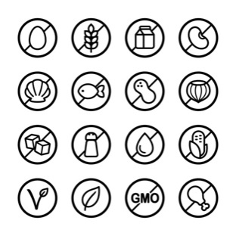**= vegan alternative upon request**

**We can also adjust most dishes to your needs.**

**STARTERS**

**CHEESE & GARLIC BREAD** 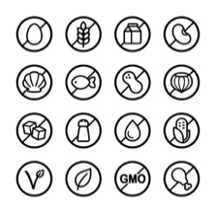

**10**

**HALLOUMI FRIES** 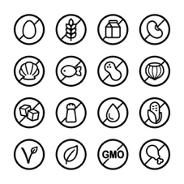

**Dusted in paprika seasoned rice flour, flash fried, with a peri-peri mayo.**

**15**

**SALT & PEPPER CALAMARI** 

**Flash fried, with lemon garlic aioli, leafy greens & lemon wedge.**

**15**

**CHICKEN SATAY SKEWERS** 

**Marinated, grilled & served on rice, drizzled with Chef’s satay sauce.**

**15**

**DUO OF DIPS** 

**Chef’s selection of house prepared dips, (please see our wait staff for today’s varieties)**

**Served with grilled flat bread**

**17**

**SUNDRIED BRUSCHETTA** 

**Grilled ciabatta bread with a sundried tomato Cream Fraiche, topped with roquette leaf, dusted with dukkah spice mix, drizzled with a balsamic glaze**

**16**

**SALADS**

**CAESAR SALAD** 

**Cos lettuce, bacon, parmesan, croutons, tossed with**

**our Chef’s Caesar dressing, topped with a poached egg, add an option of anchovies**

**20**

**Add flame grilled chicken tenderloins +6**

**Add grilled prawns +10**

**Add salt & pepper calamari +6**

**PUMPKIN & FETA SALAD** 

**Honey roasted pumpkin, with roquette, ancient grains, cherry tomato, walnuts & crumbled feta, drizzled with a honey-seeded mustard dressing.**

**24**

**SZECHUAN CALAMARI SALAD** 

**Salt & spice dusted, on a salad of julienne vegetable & mixed leaves,**

**with a Ponzu dressing.**

**26**

**ANCIENT GRAIN SALAD** 

**A selection of grains including wild rice, quinoa, lentils & pearl couscous tossed with julienne of vegetable, toasted almonds, currants, spring onion & parsley. With a pomegranate dressing.**

**25**

**TERIYAKI BEEF SALAD** 

**Marinated beef fillet, grilled & rested on a salad of mixed leaf,**

**cherry tomato, cucumber, fried shallots, sesame & bean shoots.**

**26**

**PUB CLASSICS & MAINS**

**All Pub Classics & Mains options come with your choice of Chips & Salad or our Seasonal Vegetables unless stated otherwise.**

**CHICKEN SCHNITZEL**

**24**

**CHICKEN PARMIGIANA**

**25.5**

**VEAL SCHNITZEL**

**We source & use only quality Bobby Veal.**

**28.5**

**VEAL PARMIGIANA**

**29.5**

**CHICKEN ROULADE** 

**A breast fillet filled with Brie, roasted capsicum, walnuts, wrapped with streaky bacon, rested on potato rosti, drizzled with sauce Béarnaise.**

**With seasonal vegetables.**

**29**

**NASI GORENG** 

**An Indonesian classic, Chef’s own recipe, with chicken, prawns, peas, selected Asian vegetables, wok tossed with rice. Topped with a fried egg & bean shoots.**

**28**

**STICKY WINGS** 

**With Chef’s own special marinade, oven baked, sweet, sticky & delicious.**

**25**

**FROM THE SEA**

**MAPLE GLAZED TASMANIAN SALMON** 

**With green pea risotto, blistered cherry tomatoes & pea puree.**

**29**

**FLATHEAD FILLETS**

**Deep fried in a crispy beer batter prepared using**

**“South Coast Pale Ale”, with lemon wedge & tartare sauce. Add choice of sides.**

**26**

**SALT & PEPPER CALAMARI** 

**With lemon wedge & garlic aioli choice of sides.**

**26**

**GARLIC PRAWNS** 

**Pan seared with butter & garlic, finished with a white wine cream sauce, served with rice & your choice of sides.**

**36**

**FROM THE GRILL**

**All our Beef cuts are char grilled to your liking,**

**If you prefer your meat med-well or well done, please allow extra time.**

**All Grill options come with your choice of Chips &Salad or our Seasonal Vegetables.**

**SCOTCH FILLET STEAK (300GM)** 

**Grain fed Black Angus MSA graded.**

**44**

**RIB EYE450GM** 

**Grass fed MSA graded, on the bone.**

**52**

**ADD 3 GARLIC PRAWNS TO ANY STEAK** 

**12**

**ADD A SAUCE**

**Gravy, green peppercorn, mushroom, garlic butter, béarnaise**

**$3**

**PASTA & RISOTTO**

**FETTUCCINE MARINARA**

**Selected seafoods, (inc; prawns, scallops, calamari, mussels,) pan tossed with garlic,**

**onion, tomato Napoli, a knob of butter & shaved parmesan.**

**31**

**FETTUCCINE CARBONARA**

**Pan fried with bacon, mushrooms & garlic, deglazed with white wine,**

**in a parmesan cream sauce.**

**25**

**LINGUINE SICILIANA** 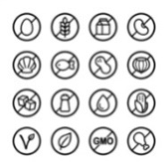

**With bacon, salami, olives, capsicum, sundried tomato, a sprinkle of chili flakes, pan tossed with olive oil.**

**26**

**BUTTERNUT PUMPKIN RISOTTO** 

**Honey roasted pumpkin nuggets, with spinach leaf, button mushrooms & roasted pinenuts pan tossed & finish with a knob of butter, with shaved parmesan.**

**25**

**LINGUINE WITH PRAWNS & CALAMARI**

**Pan seared with cherry tomato & Chorizo,**

**with olive oil, cracked pepper & parsley.**

**29**

**CHILDREN’S MENU**

**CHICKEN NUGGETS with Chips**

**FISH IN BATTER with Chips**

**CHICKEN SCHNITZEL with Chips**

**CHICKEN PARMIGIANA with Chips**

**PASTA BOLOGNESE with Tasty Cheese**

**ALL CHILDREN’S MEALS INCLUDE**

**ICECREAM & AN ACTIVITIES PACK**

**13**

**SENIOR’S MENU**

**FETTUCCINE CARBONARA**

**With bacon, mushrooms & garlic, in a parmesan cream sauce.**

**19**

**FLATHEAD FILLETS**

**Beer battered, served with lemon wedge & tartare sauce, choice of sides.**

**19**

**CHICKEN SCHNITZEL**

**Choice of sides.**

**19**

**CHICKEN PARMIGIANA**

**Choice of sides.**

**19**

**LAMBS FRY & BACON** 

**Served potato mash with seasonal vegetables & gravy.**

**19**